**WEEK 3 SPRING CORE MAVEN**

**1. Configuring a Basic Spring Application**

**Scenario:**

Your company is developing a web application for managing a library. You need to use the Spring Framework to handle the backend operations.

**Steps:**

1. **Set Up a Spring Project:**
   1. Create a Maven project named **LibraryManagement**.
   2. Add Spring Core dependencies in the **pom.xml** file.
2. **Configure the Application Context:**
   1. Create an XML configuration file named **applicationContext.xml** in the **src/main/resources** directory.
   2. Define beans for **BookService** and **BookRepository** in the XML file.
3. **Define Service and Repository Classes:**
   1. Create a package **com.library.service** and add a class **BookService**.
   2. Create a package **com.library.repository** and add a class **BookRepository**.
4. **Run the Application:**
   1. Create a main class to load the Spring context and test the configuration.

**CODE:**

//Adding Spring core dependency to pom.xml

<dependencies>

<dependency>

<groupId>org.springframework</groupId>

<artifactId>spring-context</artifactId>

<version>5.3.34</version>

</dependency>

</dependencies>

//applicationContext.xml

<?xml version="1.0" encoding="UTF-8"?>

<beans xmlns="http://www.springframework.org/schema/beans"

xmlns:xsi="http://www.w3.org/2001/XMLSchema-instance"

xsi:schemaLocation="

<http://www.springframework.org/schema/beans>

<http://www.springframework.org/schema/beans/spring-beans.xsd>">

<bean id="bookRepository" class="com.library.repository.BookRepository"/>

<bean id="bookService" class="com.library.service.BookService">

<property name="bookRepository" ref="bookRepository"/>

</bean>

</beans>

//BookRepository.java

package com.library.repository;

public class BookRepository {

public void saveBook(String bookName) {

System.out.println("Book saved: " + bookName);

}

}

//BookService.java

package com.library.service;

import com.library.repository.BookRepository;

public class BookService {

private BookRepository bookRepository;

// Setter for dependency injection

public void setBookRepository(BookRepository bookRepository) {

this.bookRepository = bookRepository;

}

public void addBook(String bookName) {

System.out.println("Adding book: " + bookName);

bookRepository.saveBook(bookName);

}

}

//MainApp.java

package com.library;

import com.library.service.BookService;

import org.springframework.context.ApplicationContext;

import org.springframework.context.support.ClassPathXmlApplicationContext;

public class MainApp {

public static void main(String[] args) {

ApplicationContext context =

new ClassPathXmlApplicationContext("applicationContext.xml");

BookService bookService = context.getBean("bookService", BookService.class);

bookService.addBook("Spring in Action");

}

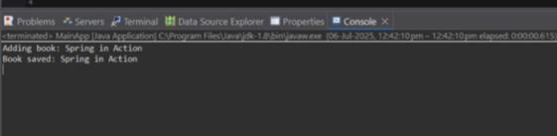

**2. Implementing Dependency Injection**

**Scenario:**

In the library management application, you need to manage the dependencies between the BookService and BookRepository classes using Spring's IoC and DI.

**Steps:**

1. **Modify the XML Configuration:**
   1. Update **applicationContext.xml** to wire **BookRepository** into **BookService**.
2. **Update the BookService Class:**
   1. Ensure that **BookService** class has a setter method for **BookRepository**.
3. **Test the Configuration:**
   1. Run the **LibraryManagementApplication** main class to verify the dependency injection.

**CODE:**

springframework.org/schema/beans

<http://www.springframework.org/schema/beans/spring-beans.xsd>">

<!-- Define BookRepository bean -->

<bean id="bookRepository" class="com.library.repository.BookRepository"/>

<!-- Define BookService bean and inject BookRepository via setter -->

<bean id="bookService" class="com.library.service.BookService">

<property name="bookRepository" ref="bookRepository"/>

</bean>

</beans>

//BookService.java

package com.library.service;

import com.library.repository.BookRepository;

public class BookService {

private BookRepository bookRepository;

public void setBookRepository(BookRepository bookRepository) {

this.bookRepository = bookRepository;

}

public void addBook(String bookName) {

System.out.println("Adding book: " + bookName);

bookRepository.saveBook(bookName);

}

}

//MainApp.java

package com.library;

import com.library.service.BookService;

import org.springframework.context.ApplicationContext;

import org.springframework.context.support.ClassPathXmlApplicationContext;

public class MainApp {

public static void main(String[] args) {

ApplicationContext context =

new ClassPathXmlApplicationContext("applicationContext.xml");

BookService bookService = context.getBean("bookService", BookService.class);

bookService.addBook("Effective Java");

}

}

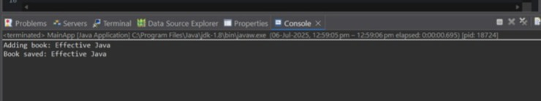

**3. Creating and Configuring a Maven Project**

**Scenario:**

You need to set up a new Maven project for the library management application and add Spring dependencies.

**Steps:**

1. **Create a New Maven Project:**
   1. Create a new Maven project named **LibraryManagement**.
2. **Add Spring Dependencies in pom.xml:**
   1. Include dependencies for Spring Context, Spring AOP, and Spring WebMVC.
3. **Configure Maven Plugins:**
   1. Configure the Maven Compiler Plugin for Java version 1.8 in the pom.xml file.

**CODE:**

//Adding spring dependencies in pom.xml

<project xmlns="http://maven.apache.org/POM/4.0.0"

xmlns:xsi="http://www.w3.org/2001/XMLSchema-instance"

xsi:schemaLocation="http://maven.apache.org/POM/4.0.0

<https://maven.apache.org/xsd/maven-4.0.0.xsd>">

<modelVersion>4.0.0</modelVersion>

<groupId>com.library</groupId>

<artifactId>LibraryManagement</artifactId>

<version>0.0.1-SNAPSHOT</version>

<packaging>jar</packaging>

<properties>

<maven.compiler.source>1.8</maven.compiler.source>

<maven.compiler.target>1.8</maven.compiler.target>

</properties>

<dependencies>

<dependency>

<groupId>org.springframework</groupId>

<artifactId>spring-context</artifactId>

<version>5.3.34</version>

</dependency>

<dependency>

<groupId>org.springframework</groupId>

<artifactId>spring-aop</artifactId>

<version>5.3.34</version>

</dependency>

<dependency>

<groupId>org.springframework</groupId>

<artifactId>spring-webmvc</artifactId>

<version>5.3.34</version>

</dependency>

<dependency>

<groupId>javax.servlet</groupId>

<artifactId>javax.servlet-api</artifactId>

<version>4.0.1</version>

<scope>provided</scope>

</dependency>

</dependencies>

<build>

<plugins>

<plugin>

<groupId>org.apache.maven.plugins</groupId>

<artifactId>maven-compiler-plugin</artifactId>

<version>3.8.1</version>

<configuration>

<source>1.8</source>

<target>1.8</target>

</configuration>

</plugin>

</plugins>

</build>

</project>

//BookService.java

package com.library.service;

import com.library.repository.BookRepository;

public class BookService {

private BookRepository bookRepository;

public void setBookRepository(BookRepository bookRepository) {

this.bookRepository = bookRepository;

}

public void addBook(String name) {

System.out.println(" Service: Processing new book addition - \"" + name + "\"");

bookRepository.saveBook(name);

}

}

//BookRepository.java

package com.library.repository;

public class BookRepository {

public void saveBook(String bookName) {

System.out.println("Repository: Successfully stored book -> \"" + bookName + "\"");

}

}

//MainApp.java

package com.library;

import com.library.service.BookService;

import org.springframework.context.ApplicationContext;

import org.springframework.context.support.ClassPathXmlApplicationContext;

public class MainApp {

public static void main(String[] args) {

ApplicationContext context = new ClassPathXmlApplicationContext("applicationContext.xml");

BookService bookService = context.getBean("bookService", BookService.class);

bookService.addBook("Clean Code: A Handbook of Agile Software Craftsmanship");

}

}

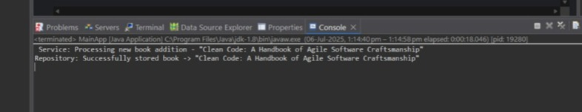

**WEEK-3**

**1.SPRING DATA JPA QUICK EXAMPLE**

//application.properties

# Logging

logging.level.org.springframework=info

logging.level.com.cognizant=debug

logging.level.org.hibernate.SQL=trace

logging.level.org.hibernate.type.descriptor.sql=trace

# Log format

logging.pattern.console=%d{dd-MM-yy} %d{HH:mm:ss.SSS} %-20.20thread %5p %-25.25logger{25} %25M %4L %m%n

# DB connection

spring.datasource.driver-class-name=com.mysql.cj.jdbc.Driver

spring.datasource.url=jdbc:mysql://localhost:3306/ormlearn

spring.datasource.username=root

spring.datasource.password=root

# Hibernate settings

spring.jpa.hibernate.ddl-auto=validate

spring.jpa.properties.hibernate.dialect=org.hibernate.dialect.MySQL5Dialect

//Create country table and sample data

create table country(co_code varchar(2) primary key, co_name varchar(50));

insert into country values ('IN', 'India');

insert into country values ('US', 'United States of America');

//Create Entity class com.cognizant.ormlearn.model.Country

package com.cognizant.ormlearn.model;

import javax.persistence.*;

@Entity

@Table(name = "country")

public class Country {

@Id

@Column(name = "co_code")

private String code;

@Column(name = "co_name")

private String name;

public String getCode() { return code; }

public void setCode(String code) { this.code = code; }

public String getName() { return name; }

public void setName(String name) { this.name = name; }

@Override

public String toString() {

return "Country [code=" + code + ", name=" + name + "]";

}

}

//Create repository com.cognizant.ormlearn.repository.CountryRepository

package com.cognizant.ormlearn.repository;

import org.springframework.data.jpa.repository.JpaRepository;

import org.springframework.stereotype.Repository;

import com.cognizant.ormlearn.model.Country;

@Repository

public interface CountryRepository extends JpaRepository<Country, String> {}

//Create service com.cognizant.ormlearn.service.CountryService

package com.cognizant.ormlearn.service;

import java.util.List;

import javax.transaction.Transactional;

import org.springframework.beans.factory.annotation.Autowired;

import org.springframework.stereotype.Service;

import com.cognizant.ormlearn.model.Country;

import com.cognizant.ormlearn.repository.CountryRepository;

@Service

public class CountryService {

@Autowired

private CountryRepository countryRepository;

@Transactional

public List<Country> getAllCountries() {

return countryRepository.findAll();

}

}

//OrmLearnApplication.java

import com.cognizant.ormlearn.service.CountryService;

import com.cognizant.ormlearn.model.Country;

import org.springframework.context.ApplicationContext;

import java.util.List;

@SpringBootApplication

public class OrmLearnApplication {

private static final Logger LOGGER = LoggerFactory.getLogger(OrmLearnApplication.class);

private static CountryService countryService;

public static void main(String[] args) {

ApplicationContext context = SpringApplication.run(OrmLearnApplication.class, args);

LOGGER.info("Inside main");

countryService = context.getBean(CountryService.class);

testGetAllCountries();

}

private static void testGetAllCountries() {

LOGGER.info("Start");

List<Country> countries = countryService.getAllCountries();

LOGGER.debug("countries={}", countries);

LOGGER.info("End");

}

}

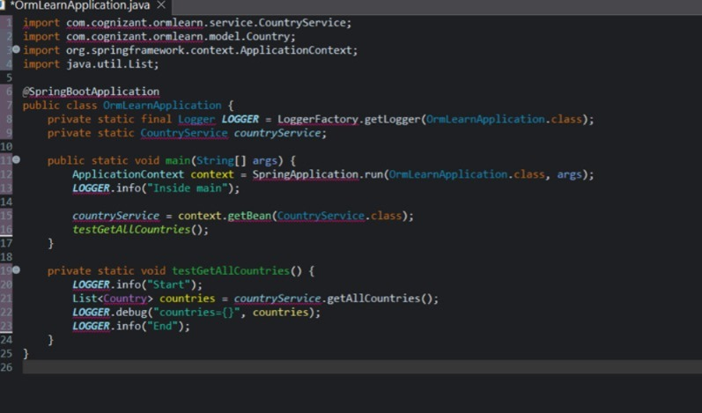

**2.Difference between JPA, Hibernate and Spring Data JPA**

* JPA (Java Persistence API) - A **specification** (interface) to define how Java objects are mapped to database tables (JSR 338). It has **no implementation**.
* Hibernate - A **concrete implementation** of JPA. It is a popular **ORM (Object Relational Mapping)** tool that provides additional features beyond the JPA spec.
* Spring Data JPA - A **Spring module** that builds on top of JPA (like Hibernate) to reduce boilerplate and provide easy integration. It uses **repository interfaces** and abstracts most of the CRUD and query logic.

//Hibernate Code

public Integer addEmployee(Employee employee) {

Session session = factory.openSession();

Transaction tx = null;

Integer employeeID = null;

try {

tx = session.beginTransaction();

employeeID = (Integer) session.save(employee);

tx.commit(); // Commit transaction

} catch (HibernateException e) {

if (tx != null) tx.rollback(); // Rollback on error

e.printStackTrace();

} finally {

session.close(); // Always close session

}

return employeeID;

}

//Spring data JPA

//EmployeeRepository.java

public interface EmployeeRepository extends JpaRepository<Employee, Integer> {

// Inherits methods like save(), findById(), findAll(), delete(), etc.

}

//EmployeeService.java

@Service

public class EmployeeService {

@Autowired

private EmployeeRepository employeeRepository;

@Transactional

public void addEmployee(Employee employee) {

employeeRepository.save(employee); // One-liner

}

}

